Title: Research Methods and Critical Enquiry

Oonagh Devoy
In this paper I will discuss, explore and critically evaluate my personal research and critical enquiry in relation to the Masters Programme. I will reflect and critically evaluate selected subjects and methods which I have identified as key to my own development detailing how, why and where these have been applied.

In my fourteenth year as a lecturer in Further Education and my teenage daughter making her way boldly into the world I commenced my search for an opening in which to kick start my studio practice, challenge myself academically and to forge new metaphorical and human connections. This opportunity presented itself in the form of the Masters Programme at Gray’s School of Art and my journey began when I generated my proposal for the application process.

In my proposal I was very clear about what I wanted to accomplish and the methods that I wished to employ. It had not been difficulty to draw up the two year plan of action. Therefore it took me completely by surprise the extent to which I would be shaped by the seminar programme and also how much it would influence and enhance my initial proposal.

It is truthful to say that every one of the twelve seminars has informed and impacted on my current practice however in this paper I will concentrate by critically reflecting on the seminars that have inspired me the most.

The seminar entitled ‘Literature Reviewing and Analysis’ was the first to make an imperative impact on me. Our homework had been to read and analyse a text that had been chosen for us. I had been given chapter three of Making is Connecting: The social meaning of creativity, from DIY and knitting to YouTube and web 2.0, (Gauntlett, 2011).

From the title alone I was hooked in what promised to be my first link to likeminded thinkers and practitioners. The text rewarded accordingly providing an easy to read dissemination of the merits and pleasure experienced by visual artists, craftspeople and DIY enthusiasts. The reading of one chapter however did not satisfy and I was compelled to buy the book. In his opening chapter Gauntlett breaks down into three parts the meaning of the title of the book. I related most especially with the third, “Making is connecting because through making things and sharing them in the world, we increase our engagement and connection with our social and physical environments”, (Gauntlett 2011 p. 30).

I am no stranger to investing in books that inform and influence my practice however when I compared my new book to my past purchases I realised that I had acquired a volume that critically and academically analysed the ‘making of art’; my previous books had been either technical instruction manuals or the illustrated works of artists/photographers. For the first time I had consumed a text that strengthened my contextual knowledge by way of argument instead of instruction. This led me to search for the voices of other critical thinkers and I found them via a variety of sources; online, newspapers, television and radio.

This new found empowerment whereby language through analysis and dissemination could further inform and underpin the context of my proposal led me to my next book, Critical terms for art history, 2nd ed, (NELSON, R and SHIFF, R., eds., 2003). During one of our tutorials I had been challenged by a classmate to explain why I had used the word ‘beauty’ to describe my found objects. Articulating the answer was more complex than I realised. Objects that are beautiful to me are not automatically beautiful to others, ergo define ‘beauty’. My specialist tutor David Blyth advised me to read Chapter 18 of the above text. “Where beauty lies is a genuine difficulty that philosophers have been unable to resolve.” (NELSON, R and SHIFF, R., eds., 2003 p.273). Far from providing the holy grail of knowledge it offered a definition that made me further question my use of terminology. I proceeded to read the next chapter entitled ‘ugliness’. It defined ugly as, “Simply put, ugliness is an aesthetic category that stands at the opposite of beauty” (NELSON, R and SHIFF, R., eds., 2003 p. 281). I was perplexed at the narrow and bland definitions of these words that did not embrace or celebrate diversity. I now realised that what I often consider to be beautiful many people would think the opposite and vice versa with ugly. It was time to re-examine my proposal in a bid to critically strengthen the context of my work.

Figure 1 – (Devoy 2016)

In our fourth seminar entitled “Collaboration as Process”, David Blyth invited us to consider not only working with artists but contemplate working with professionals in different fields of expertise, "you cannot discriminate where knowledge comes from...........the resulting combined wisdom offers the possibility of discovering new knowledge" (Blyth, 2015). An article in The Guardian online, We should look beyond economics and open our eyes to beauty, (Reynolds 2016), took my interest. “Then, beauty mattered enough to shape policy for the public good. And so after the horror of two world wars, the 1945 government implemented a package of measures designed not only to meet people’s basic human needs but also their spiritual, physical and cultural wellbeing”. David was right; here was a National Trust director general and author, articulating ideas and arguments that I agreed with. Our desire was mutual, wishing people to engage in and appreciate their environment; however we expressed this opinion in different formats.

Feeling inspired by the written word I decided it was time to broaden my output and begin to express my thoughts, ideas and reflections through literature. My new voice manifested itself in the creation of a website and accompanying blog. The home page contextualised the subsequent pages which I revisit and curate regularly as my work evolves and develops. I have disciplined myself to write a blog entry once a week. Entries take the form of a reflection, an observation, an achievement, a failure or a link to something that has interested/inspired me. In writing I have found another method in which to articulate and form opinions critically and academically.

The next seminar in the Masters Programme that affected me deeply was, “Born again: Visual methods as research. Understanding and using your arts practice as research: A focus on photography and film.” In this seminar our lecturer Charlie Hackett invited us to consider using film and photography as a research tool. To establish the methodology as part of our current practice we were set an assignment to storyboard a film contextualising our Masters work. This would in turn lead onto the production of a short film that would be submitted as part of our portfolio for the PGDip.

I was excited to begin the project being comfortable and proficient with both cameras and editing software. However my storyboard was weak and although I produced a satisfactorily edited short film it failed to fulfil the brief because it did not contextualise my practice. With no narrative it resembled a bizarre pop video whose meaning was to be guessed at.

It was time to revisit my proposal and generate another storyboard. I realised then that my proposal should be the narrative. A visit to Orkney which has inspired much of my collecting would be the backdrop. My proposal would take the form of a message encapsulated in a bottle along with objects that I had found washed upon the shoreline. Added to my message would be an invitation to the ‘finder’ to respond and share their definition of the word ‘beauty’. My hope was that at some point my bottle would be found and I would forge a new connection but if that didn’t happen I would not be dissatisfied as the making of the bottle had given me pleasure enough.

My second film satisfied the brief however this time I was frustrated by the quality of the sound and I began to do some research on the internet looking at microphones. A tutorial and review on YouTube led to me purchasing a USB microphone called a Blue Yeti and another video provided me with the instructions on how to make a portable sound booth to further improve the sound quality:

- (JayzTwoCents 2015) https://www.youtube.com/watch?v=PzHW6Jybp9g

- (Media6D 2016)
https://www.youtube.com/watch?v=rWgLCPaOAzo
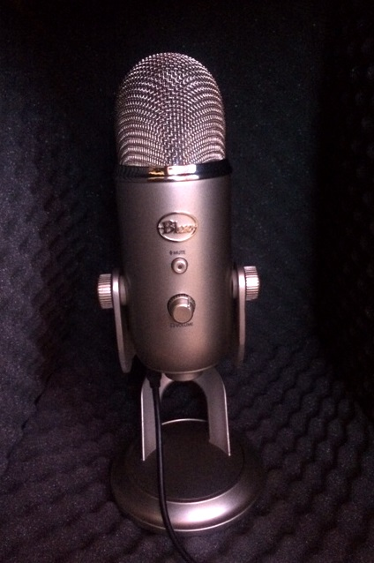
Figure 2 – Devoy 2016)
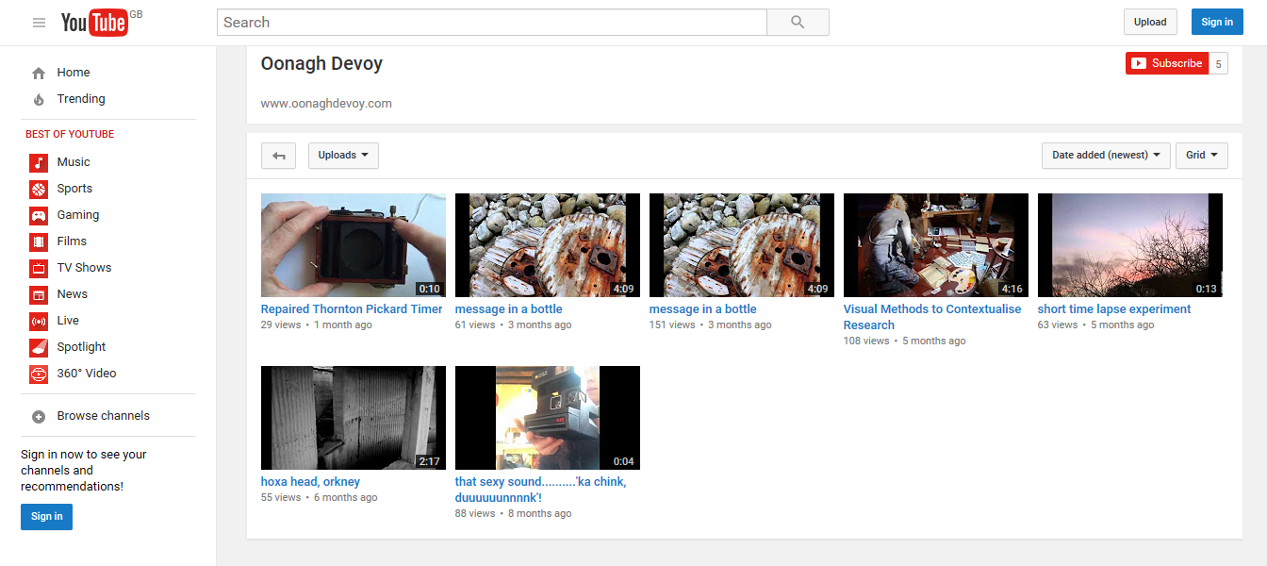Figure 3 – (Devoy 2016)

The final edit was significantly better and I was satisfied that I had finally fulfilled the brief to my best abilities.

The conclusion of the task subsequently inspired the production of new works and projects for me. After I had launched my ‘message in a bottle’ I began to investigate accounts of ‘messages in a bottle’ that had been discovered in the past and was surprised to discover a variety of motivations behind the action; a call for assistance, an act of love, a scientific survey or just plain wonder and the chance of forging a new connection. A couple of days later a news item appeared regarding the oldest ‘message in a bottle’ to be discovered. “When the distinguished marine biologist threw his message in a bottle into the sea, asking whoever found it to contact him, he wasn’t expecting a speedy response. Which is just as well, because it took just over 108 years” (Kennedy 2016). I was completely captivated and decided to continue launching more bottles from various locations. It was not important to me that the bottles were found in my lifetime, the mode of delivery already proven by history to be unreliable. Nevertheless, I believe my bottles contain a message that will be as relevant in the far distant future as I consider it is today.

To date I have made seven bottles though they have not all been launched by me. Four of these have been cast to the seas by friends who have asked to be part of the performance, touched by the concept of inspiring the ‘sense of wonder’ in others and rediscovering it themselves.
Figure 4 – (Devoy 2016)

Figure 5 – (Devoy 2016)

In the middle of May we had a feedback review with our principal lecturer Iain Irving to discuss the progress of our work to date. My feedback was positive but I was prompted to critically reflect on my studio practice and I was given a list of sources to examine further. An observation that took me aback was, 'There is actually quite a bit of performance in the work being produced. Is this work about you?' (Irving 2016). For the first time I acknowledged that yes, this work was as much about my identity and connecting as it was about engaging with the world.

Mulling over my review feedback sheet recommendations I began to examine the work of the writer Dr Robert Macfarlane. “I am interested in the way in which our minds and our moods and our imaginations and our identities are influenced by the textures and the weathers and the forms and the slopes and the curves and the creatures, remembered and actual, of the places we inhabit. I am interested in the ways in which the feel of the world influences our feeling of the world” (Macfarlane 2012). MacFarlane’s lecture resonated, and provided the inspiration for my next concept. The film I had completed for Charlie had satisfied the brief but as with all that I have experienced to date on the Master course, as one question is answered another one precipitously takes it place. I now wanted to make another film that would explain my connection with the landscape and the objects I collect. I searched introspectively to find the narrative of my next project and surprised myself writing a piece of poetry; a stream of consciousness.

i’m lost
i’m very lost
wandering aimlessly
i’m always losing my way
no sense of direction you see

but she comforts me
let’s me walk alongside her
doesn’t speak
just listens

she’s an old friend

i am older
older than i think i am
but that doesn’t disturb me
i’m comfortable in my skin

only that i’m still lost
i don’t know the way
i just don’t know where i’m going

The poem expresses the juncture I find myself in my life and work and how walking along the coastline helps me to solve problems.

I have not planned how many other pieces I need to write. When I am happy with my text I will begin to visualise, storyboard then film. The time in between I will use to investigate the works of filmmakers who moved me when we visited the British Art Show in Edinburgh and The Turner Art Prize in Glasgow earlier this year with Iain Irving. My specialist tutor David Blyth has introduced me to the films of Lindsay Seers also.

In conclusion, I commenced my studies at Gray’s School or Art in September 2015 as a focused and eager student with a plan of action and a defined list of the methods and methodologies that I wished to employ. Without a doubt the seminar programme has malleably enhanced my proposal and enabled me to mature critically. Before I began the course, although I had strong themes that I visited and revisited, I had not researched the meaning behind what moved me or critically reflected on the works I produced. The course has introduced me to a world of thinkers and makers that have informed and inspired me to produce concepts and works that I couldn’t have achieved without their influence. I can now academically defend myself when questioned about aspects of my work and if I am unsure of the answer I am humble enough to say I don’t know and motivated enough to make further enquiries both as a reflective practitioner and a researcher. The methodology and methods I employ have expanded exponentially. Before I would look at the work of other visual artist and photographers for inspiration, now I am reading and listening to lectures of practitioners from a variety of fields of expertise.

My initial Masters proposal had been to produce works in paint and photography. Currently as a result of the seminar programme my methods now include performance, video and prose. The platforms for my work have augmented and I have created an online presence by means of a website, blog, YouTube and Soundcloud. My specialist tutor David Blyth has encouraged me to consider non-traditional venues in which to output my work. The oceans where not what he suggested but without a doubt the venue is non-traditional!

I have also formed new links and opportunities that extend out with Gray’s School of Art. I have secured a one woman show at Angus Councils flag ship gallery in Forfar, The Meffan Institute, to showcase my Masters work in 2018. I am also collaborating with the classical composer David Ward. David will be composing a score for cello and piano inspired by my Masters proposal and I will be creating a video to accompany. The completed collaboration will be performed at the Woodend Barn in Banchory as part of the Sound Festival in 2017.

Unquestionably the Masters seminar programme has shaped me into a critical and reflective practitioner. My studio practice has not only been kick started but it has also evolved as my research practice has developed.

I would like to end this paper with a quote from the naturalist, author and environmental philosopher, John Muir; yet another writer I may have overlooked if it had not been for this course. Although I am an atheist the quote embodies how I myself feel about the landscape; a connection which brings out the sense of wonder in me, helps me work out my problems and moves me to create my works. “Everybody needs beauty as well as bread, places to play and pray in, where Nature may heal and cheer and give strength to body and soul alike” (Muir 1986 p.256)

Reference List

GAUNTLETT, D., 2011. Making is connecting. The social meaning of creativity, from DIY and knitting to YouTube and Web 2.0. Cambridge, UK: Polity.

NELSON, R and SHIFF, R., eds., 2003. Critical terms for art history, 2nd ed. London: The University of Chicago Press.

BLYTH, D., 2015. Collaboration as Process. [lecture]. Research Methods and Critical Enquiry Module. The Robert Gordon University, Grays School of Art, Garthdee House, room SB37c, 20 November 2015.

REYNOLDS,F., 2016. We should look beyond economics and open our eyes to beauty. [online]. London: Guardian. Available from: https://www.theguardian.com/commentisfree/2016/jun/02/beyond-economics-open-eyes-to-beauty-nature [Accessed 2 June 2016].

JAYZTWOCENTS, 2015. Blue Yeti Review and Setup Guide - How to get the best sound. [online video]. 28 January. Available from: https://www.youtube.com/watch?v=PzHW6Jybp9g [Accessed 16 April 2016].

MEDIA6D, 2013. DIY Portable Sound Booth - Test & Review. [online video]. 23 June. Available from: https://www.youtube.com/watch?v=rWgLCPaOAzo [Accessed 16 April 2016].

KENNEDY, M., 2016. Message in a bottle, promising finder a shilling, bobs up after 108 years. [online]. London, Guardian. Available from: https://www.theguardian.com/world/2016/apr/19/message-bottle-washed-ashore-108-years-worlds-oldest [Accessed 19 April 2016].

IRVING, I., 2016. Review Feedback. [tutorial]. Research Methods and Critical Enquiry Module. The Robert Gordon University, Grays School of Art, Garthdee House, room SB37c, 20 May 2016.

IQSQUARED, 2012. Robert Macfarlane on landscape and the human heart - IQ2 Talks. [online video]. 22 June. Available from: https://www.youtube.com/watch?v=5q1IK-O5Ypg [Accessed on 21 May 2016].

MUIR, J., 1986. The Yosemite. London, UK: Wisconsin.

Bibliography

CRAWFORD, M., 2009. The case for working with your hands. Or why office work is bad for you and fixing things feels good. London, UK. Penguin books.

Illustration list

Figure 1, DEVOY, O., 2016. Object collected from shoreline. Published photograph
Figure 2, DEVOY, O., 2016. Blue Yeti Microphone and homemade sound booth. Published photograph
Figure 3, DEVOY, O., 2016. YouTube account. Unpublished photograph. Published photograph
Figure 4, DEVOY, O., 2016. First message in a bottle, Shapinsay, Orkney. Published photograph
Figure 5, DEVOY, O., 2016. Objects enclosed in first message in a bottle. Published photograph

